**MIS 381N**

**Stochastic Control and Optimization Homework 3**

**Jushira Thelakkat (jt39634)**

**Problem 1**

It costs a company $12 to purchase an hour of labor and $15 to purchase an hour of

capital. If L hours of labor and K units of capital are available, then 0.05(L)^2/3(K)^1/3 machines

can be produced. Suppose the company has $100,000 to purchase labor and capital.

What is the maximum number of machines it can produce?

Here we have 12L+15K = 100000

We want to maximize the number of machines produced. This can be done using the optim

function on R.

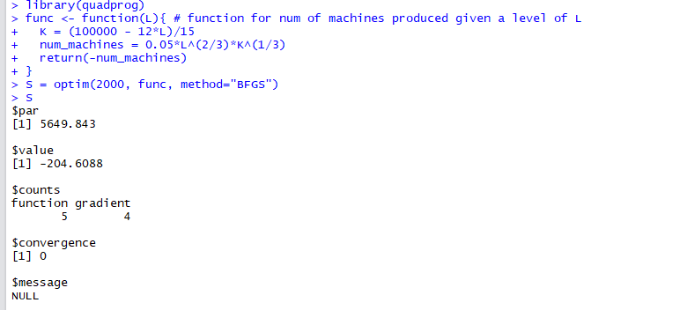



The maximum number of machines that can be produced is 204.

**Problem 2**

The file homework4stocks.csv contains historical monthly returns for 27 companies. The

first row contains stock names and the first column contains the dates. For each

company, calculate the estimated mean return and the estimated variance of return. Then

calculate the estimated correlations between the companies’ returns.

Find a portfolio that achieves an expected monthly return of at least 1% and minimizes

portfolio variance. What are the fractions invested in each stock? What are the portfolio’s

estimated mean, variance, and standard deviation?

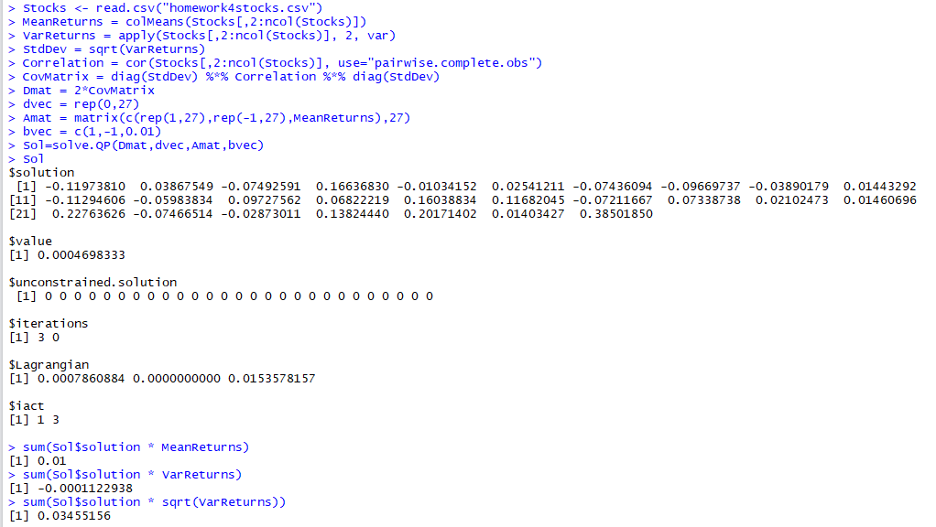



The mean return of the new portfolio is 1%, the variance is -0.0001122 (the minimized value) and the standard deviation is 0.0345. The fractions invested in each stock are given below



**Problem 3**

The file ‘variable_selection.csv’ contains observations of variables y, x1, x2, and x3. Here, y

is the dependent variable. We want to choose a linear model that uses at most 2

independent variables such that the sum of squared residuals is minimized. This can be

formulated as a constrained quadratic programming problem.

This is called best subset problem which is usually very hard to solve. We will solve this

problem by enumeration. Run six OLS regressions (3 with one independent variable and 3

more with two variables each) and choose the regression that best fits the data.

It's just 6 linear regression. This is the toy problem to let you warm up for your project. In

your project, you will do it in the systematic NLP way.

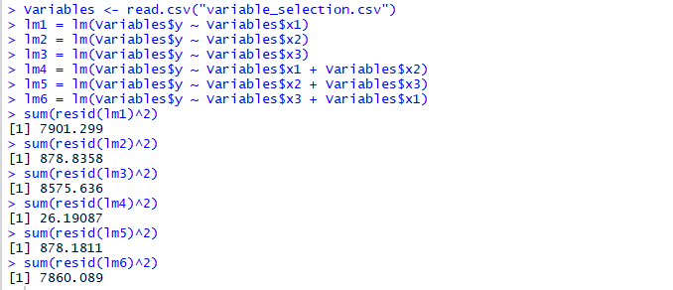



We want the least sum of squared residuals and from the results above, we find that the fourth regression which includes both x1 and x2 has the least SSR.

**Problem 4**

In an electrical network, the power loss incurred when a current of I amperes flows through

a resistance of R ohms is I2R watts. In the figure below, 710 amperes of current must be

sent from node 1 to node 4. The current flowing through each node must satisfy

conservation of flow. For example, for node 1, 710 = flow through 1-ohm resistor + flow

through 4-ohm resistor. Remarkably, nature determines the current flow through each

resistor by minimizing the total power loss in the network.

**1.** Formulate a quadratic programming problem whose solution will yield the current

flowing through each resistor.

Choose x1, x3, x4, x6 and x12  
The objective here is to minimize sum(xi2 * i)  
Constraints:  
x1 + x4 = 710; x6 + x12 = x1 –> x1 + x6 + x12 = 0; x3 = x4 + x6 –> x3 - x4 - x6 = 0

**2.** Use R to determine the current flowing through each resistor.

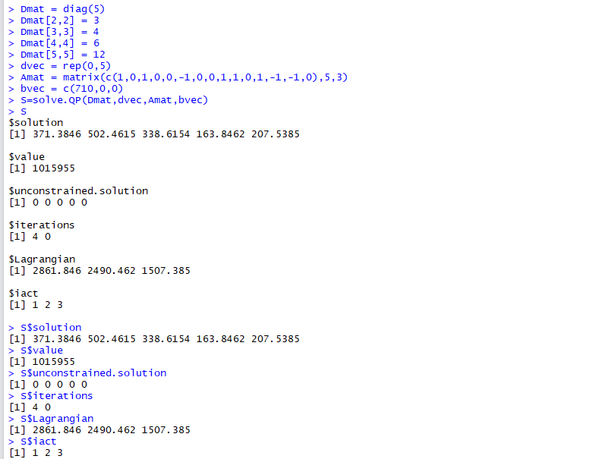



Therefore, from the results, we see that the current flowing through each resistor is shown below (in ohms)



**Problem 5:**

The file nflratings.csv contains the results of 256 regular-season NFL games from the 2009

season. The teams are indexed 1 to 32 as shown below:

The csv data file contains a matrix with the following columns:

• Week (1-17)

• Home Team Index (1-32 from the table above)

• Visiting Team Index (1-32 from the table above)

• Home Team Score

• Visiting Team Score

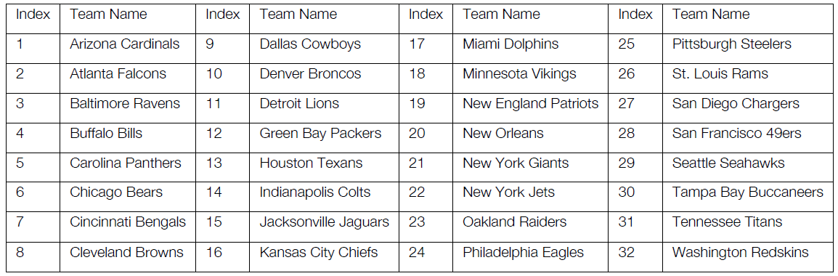

You will need to calculate the following:

• Actual Point Spread = Home Team Score – Visiting Team Score

• Predicted Spread = Home Team Rating – Visitor Team Rating + Home Team

Advantage

• Prediction error = Actual Point Spread – Predicted Point Spread

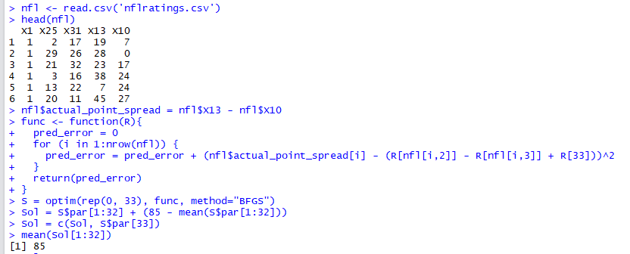

Below are the ratings for the 32 NFL teams.



The last number is the home team advantage.